Diagrams:

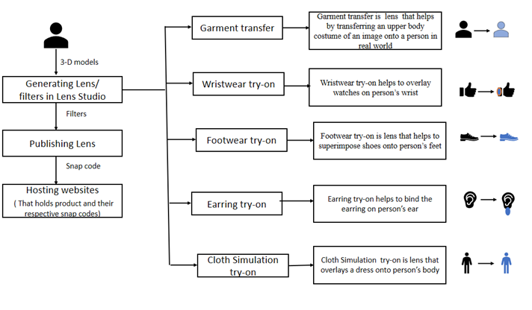

**Figure 1 Workflow with respect to the seller.**

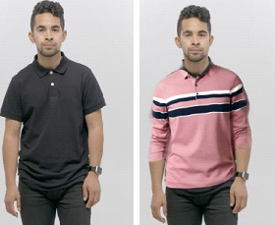

Figure . Image of a person before and after using garment transfer

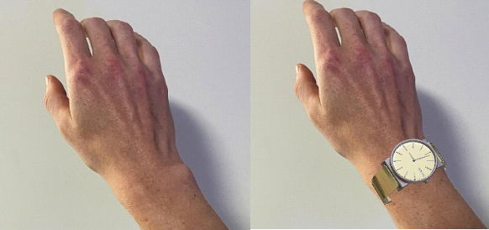

Figure Image of a person’s hand before and after using wristwear try-on.

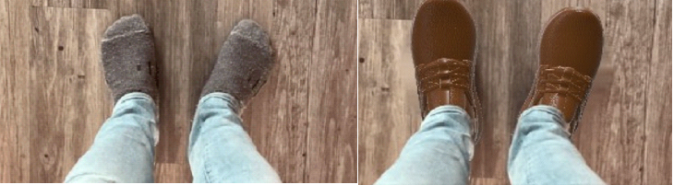

Figure Feet of a person before and after using footwear try-on.



Figure . Image of a person before and after using earring try-on.

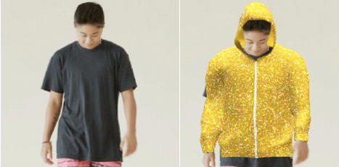

Figure Image of a person before and after using cloth simulation try-on.

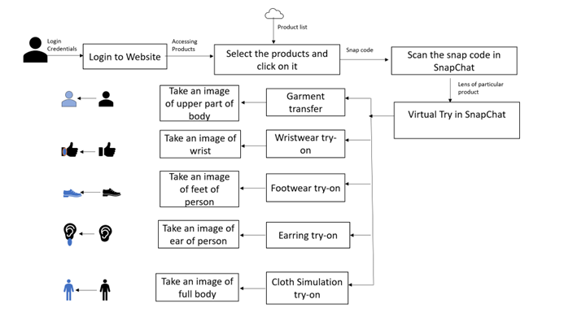

Figure . The process that customers can follow.

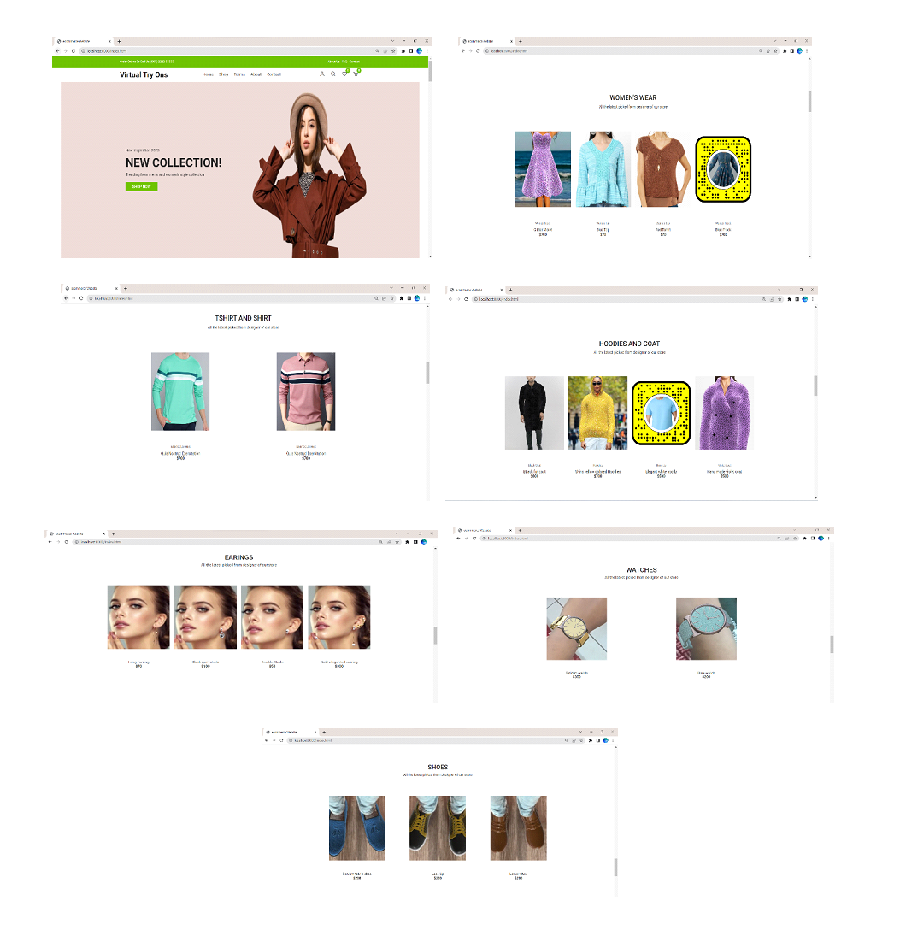

Figure Website with preview on the card and snap codes on the back of the card.

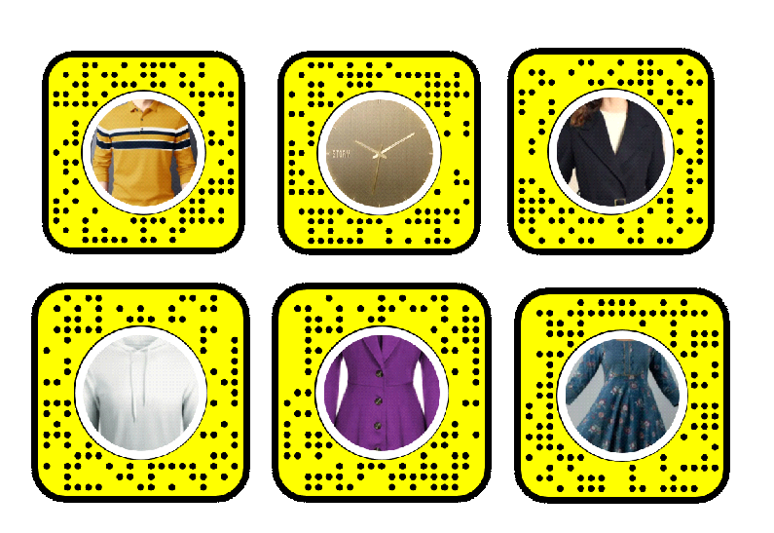

Figure . Snap codes of the lenses